Go to the Task 1 page at <https://challenge2018.isic-archive.com/task1/training/>

Click on the first paragraph on the link in the text “downloaded from the challenge submission site”.

At this page at the bottom left there is a button labeled “Download Training Dataset”.

Click it with the RIGHT mouse button and choose “Copy Link Address” (or similar text depending on your browser).

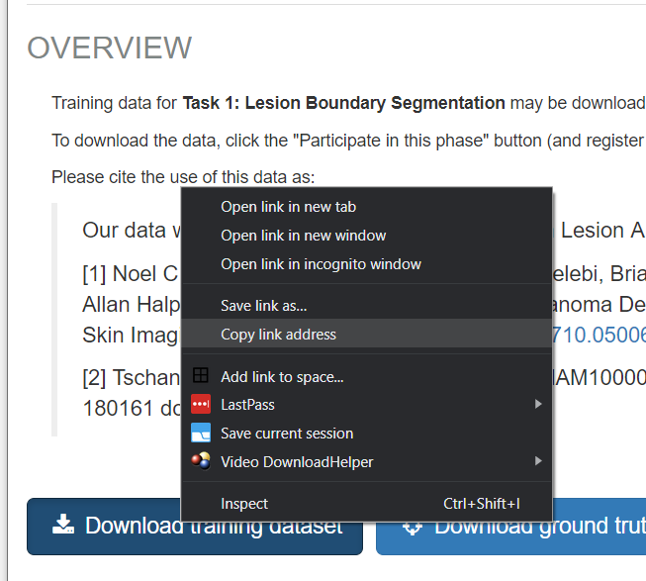

In Colab page, paste the link into a cell like this and execute it:

**!wget *{pasted URL goes here}***

When this is run, you should see the file downloading. However it might not be with the correct name, but with the filename **‘download’**, so has to be renamed, for example:

!mv download ISIC2018_Task1-2_Training_Input.zip

And then unzipped:

!unzip ISIC2018_Task1-2_Training_Input.zip

The same can be done with the other link in the page (ground truth data).

If needed, repeat the same procedure with parts 2 and 3 which are at URL:

<https://challenge2018.isic-archive.com/task2/training/>

<https://challenge2018.isic-archive.com/task3/>

**Advanced**:

If you applied the mounting of your Google drive to be access from Colab:

from google.colab import drive

drive.mount('/content/gdrive')

Then your Google drive is probably accessible at:

/content/gdrive/My\ Drive/

And it might be preferable to store the files there, e.g. after download do this:

!mkdir /content/gdrive/My\ Drive/BootCamp

!mv download /content/gdrive/My\ Drive/BootCamp/ISIC2018_Task1-2_Training_Input.zip

!unzip /content/gdrive/My\ Drive/BootCamp/ISIC2018_Task1-2_Training_Input.zip

Then change the path pointing to the input data accordingly (pay attention to the directory created by the Unzip command).